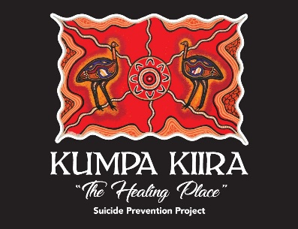
Permission Form
Coomealla Health Aboriginal Corporation runs a range of programs where permission notes are necessary for young people aged under 18 years of ages. The information collected allows CHAC to be confident that:
- We have background details which will assist in planning events and accommodation any special needs of your child.
Event/ Activity Name | Koori Holiday Program 2022
Child Name
Adress
Date OF Birth
Gender
Child Medical Conditions/Allergies/Special needs including medication | Please list any conditions
Emergency contact details | NAME  Telephone  Relationship to child
Consent to use photography or recorded image | Consent given to coomealla health aboriginal corporation photographer appointed by CHAC to capture and use any photograph/image of child named above for the purposes of publicising and promoting CHAC eg newspaper, Facebook, funding body  YES NO
 | I hereby give permission for the child named above to participate in the event/activity named above. I have had the details of the event explained to me by a chac staff member and understand any risk associated with the event
Name:  Signed: |  | Date:
Your relationship to child
Your contact details | Phone:  Address:
- You have given your child permission to participate in the activities listed below.

Limited spots available on transport.
Please contact Jaharlyn or Bonnie regarding transport.

