Our Reference: | DOC/21/23122
Prepared By: | Michele Bos
Date: | 14/10/2021
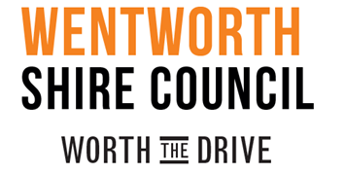

EXPRESSION OF INTEREST FOR MEMBERSHIP AS A COMMUNITY REPRESENTATIVE ON THE WENTWORTH SHIRE COUNCIL FLOOD RISK MANAGEMENT COMMITTEE
To: Ken Ross, General Manager
I wish to register my interest for membership as a Community Representative on the Wentworth Shire Council Flood Risk Management Committee.
I understand that:
- the membership includes voting responsibility as a Community Representative
- the committee will meet periodically as required
- the term of membership will be for a period of three (3) years

EXPRESSION OF INTEREST - PERSONAL DETAILS
Name

Company Name (if applicable)

Postal Address

Contact No.

Email

Signature / Date

